**Delhi Technological University**

**CO – 204**

**COMPUTER ORGANISATION AND ARCHITECTURE**

**PROJECT**



**Submitted To: Dr. Pawan Singh Mehra**

**COA Faculty, DTU**

**Submitted By:**

**Name :** **Roll No:**

SHACHI INTODIA 2K19/CO/350

SHIKHAR CHAUHAN 2K19/CO/359

**Topic: *Fight Against Covid* – Smart Social Distancing Indicator and Alarming System and Smart Sanitization Tunnel**

**ACKNOWLEDGMENT**

We (Shikhar Chaunhan and Shachi Intodia) would like to express our sincere gratitude to our supervisor Mr. Pawan Singh Mehra for providing his valuable guidance, comments and suggestions throughout the course of the project. We would like to thank him for providing us the opportunity to work on the topic - “Fight Against Covid – Smart Social Distancing Indicator and Alarming System and Smart Sanitization Tunnel” and analyze the current situation.

We would also like thank my fellow classmates who have been very supportive and have motivated us throughout the course of the project.

Lastly, we would like to mention our parents who have helped and guided us to focus on our project. They taught us the basic ethical principles that one must follow in life which has ultimately led to the successful completion of the project.

We hope you have a great time while reading the project!

**CONTENTS**

**S.No. TOPIC Page**

1. Introduction 4
2. Social distancing indicator and alarming system 5
3. Components and their Description 5
4. Circuit, Principle and Working of Circuit 8
5. Code 10
6. Simulation 12
7. Practical Use 16
8. Smart disinfection and sanitization tunnel 17
9. Components and their Description 17
10. Circuit, Principle and Working of Circuit 21
11. Code 22
12. Simulation 23
13. Practical Use 24
14. Bibliography 25

**INTRODUCTION**

Coronavirus disease 2019 (COVID-19), also known as the coronavirus or COVID, is a contagious disease which can be easily spread from person to person if not taken appropriate precautions. The main idea behind creating this project is to prevent the spread of COVID-19.

The Smart Social Distancing Indicator and Alarming System will come in handy to keep the 6 ft distance amongst each other and the Smart Disinfection and Sanitation Tunnel is a demonstration of how to provide maximum protection to people passing through the tunnel in around 15 seconds which can help the community to fight against the COVID-19.

These circuits can be used in various industries and will prove to be of great help in these challenging times of pandemic.

**SOCIAL DISTANCING INDICATOR AND ALARMING SYSTEM**

* **COMPONENTS**

|  |  |  |  |
| --- | --- | --- | --- |
| **SR. NO.** | **COMPONENT** | **SPECIFICATIONS** | **QUANTITY** |
| 1 | Arduino Uno | R3 | 1 |
| 2 | Piezo Buzzer | 5V | 1 |
| 3 | Ultrasonic Distance Sensor | HC-SR04 | 1 |
| 4 | Neo Pixel Ring | 12 X 5050 RGB LED | 1 |

* **DESCRIPTION OF COMPONENTS**
* **Arduino Uno R3**

The Arduino Uno is a microcontroller board based on the ATmega328. It has 20 digital input/output pins (of which 6 can be used as PWM outputs and 6 can be used as analog inputs), a 16 MHz resonator, a USB connection, a power jack, an in-circuit system programming (ICSP) header, and a reset button.  Programs can be loaded on to it from the easy-to-use Arduino computer program, [Arduino IDE](https://en.wikipedia.org/wiki/Arduino#Software) (Integrated Development Environment), via a type B [USB cable](https://en.wikipedia.org/wiki/USB_cable). It can be powered by the USB cable or by an external [9-volt battery](https://en.wikipedia.org/wiki/9-volt_battery), though it accepts voltages between 7 and 20 volts.

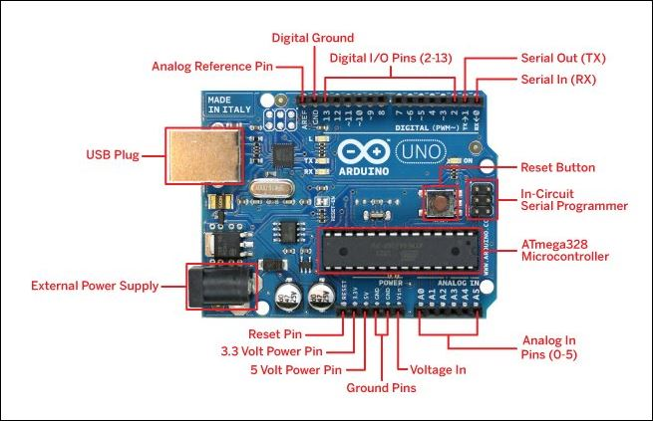

* 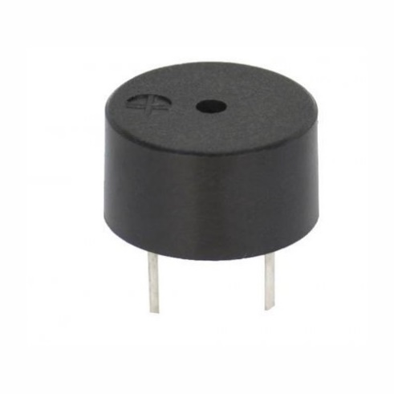**Piezo Buzzer**

A piezoelectric speaker (also known as a piezo bender due to its mode of operation, and sometimes colloquially called a piezo, buzzer, crystal loudspeaker or beep speaker) is a [loudspeaker](https://en.wikipedia.org/wiki/Loudspeaker) that uses the [piezoelectric effect](https://en.wikipedia.org/wiki/Piezoelectric_effect) for generating [sound](https://en.wikipedia.org/wiki/Sound). The initial mechanical motion is created by applying a voltage to a piezoelectric material, and this motion is typically converted into audible sound using diaphragms and resonators. Typically they operate well in the range of 1-5 kHz and up to 100 kHz in ultrasound applications.

* **Ultrasonic Distance Sensor**

An ultrasonic sensor is an electronic device that measures the distance of a target object by emitting ultrasonic sound waves, and converts the reflected sound into an electrical signal. Ultrasonic waves travel faster than the speed of audible sound (i.e. the sound that humans can hear). Ultrasonic sensors have two main components: the transmitter (which emits the sound using piezoelectric crystals) and the receiver (which encounters the sound after it has travelled to and from the target).

In order to calculate the distance between the sensor and the object, the sensor measures the time it takes between the emission of the sound by the transmitter to its contact with the receiver. The formula for this calculation is [**D = ½ T x C**](https://www.arrow.com/en/research-and-events/articles/ultrasonic-sensors-how-they-work-and-how-to-use-them-with-arduino) (where D is the distance, T is the time, and C is the speed of sound ~ 343 meters/second).

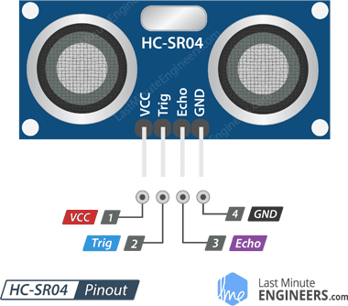

The ultrasonic distance sensor has the following pins :

**VCC** – Vcc is the power supply for HC-SR04 Ultrasonic distance sensor which we connect the 5V pin on the Arduino.

**TRIG** (Trigger) - Trigger pin is used to trigger the ultrasonic sound pulses.

**ECHO** – Echo pin produces a pulse when the reflected signal is received. The length of the pulse is proportional to the time it took for the transmitted signal to be detected.

**GND** (Ground) – Ground should be connected to the ground of Arduino.

* **Neo Pixel Rings**

NeoPixel rings are circular rigid printed circuit boards festooned with NeoPixel LEDs. NeoPixel rings are offered in 12, 16, 24 and 60 pixel varieties.

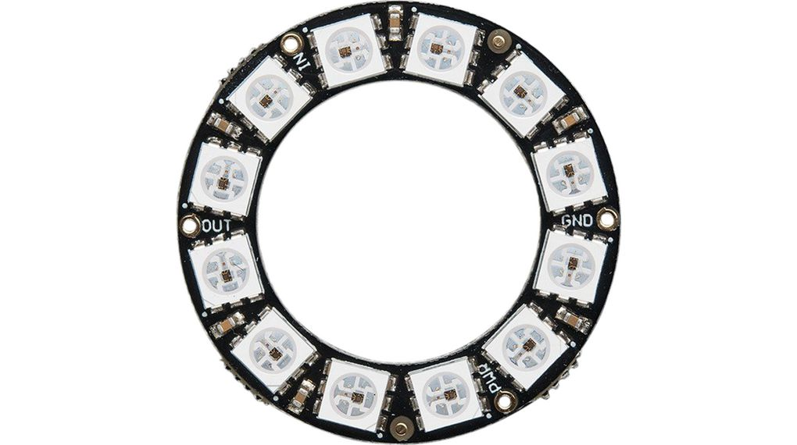

* **CIRCUIT**

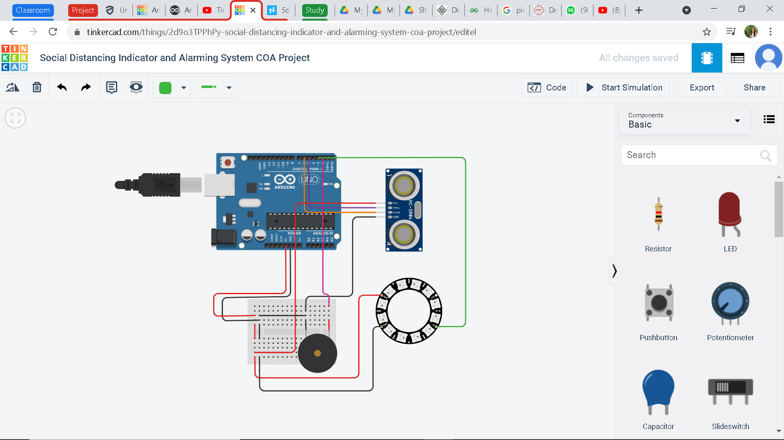

* **PRINCIPLE**

The unltrasonic distance sensor measures the distance

Number of LEDs glow up corresponding to the distance measured

If number of LEDs glowing is equal to 12, then the buzzer starts ringing

* **WORKING OF CIRCUIT**

The connections are made according to the circuit diagram shown above. The Arduino Uno board is connected with a PC using a USB cable. The code written in Arduino Uno IDE is loaded into the Arduino Uno board.

After powering up Arduino Uno board, the circuit becomes functional. 5 V supply is given to the piezo buzzer, ultrasonic distance sensor and neopixel ring. A pulse of atleast 10 µS (10 microseconds) in duration is applied to the Trigger pin of the ultrasonic sensor. In response to that the sensor transmits a sonic burst of eight pulses at 40 KHz. The eight ultrasonic pulses travel through the air away from the transmitter. Meanwhile the Echo pin goes HIGH to start forming the beginning of the echo-back signal. In case, If those pulses are not reflected back then the Echo signal will timeout after 38 mS (38 milliseconds) and return low. Thus a 38 mS pulse indicates no person is in close vicinity and the person with the sensor is safe from being infected. If those pulses are reflected back the Echo pin goes LOW as soon as the signal is received. This produces a pulse whose width varies between 150 µS to 25 mS, depending upon the time it took for the signal to be received. The width of the received pulse is then used to calculate the distance to the reflected object using the given formula.

**Distance = Speed of Sound X (Time/2)**

Distance = Time / (29 * 2)

Distance = (Time µS * 0.034 cm/µS) / 2

The neopixel ring is divided into 12 ranges between 100 to 400 meters and each LED corresponds to each of these 12 ranges. Based on the distance detected by the ultrasonic sensor, corresponding number of LEDs light up. The first four LEDs are green (SAFE) in colour which indicate the person is at safe distance. Next four LEDs are yellow ( ) in colour which indicate that precaution should be taken, and the next four are Red (DANGER) in colour to indicate close proximity of a person and the need to immediately move away to a safe distance. When the distance detected by the ultrasonic sensor is less than 100 meters, all the 12 LEDs of the neopixel ring light up and this causes the piezo buzzer pin to get a HIGH input and thus the buzzer starts ringing giving an auditory indicator to maintain a safe distance.



**RED - DANGER**

**GREEN - SAFE**

**YELLOW -**

* **CODE**

#include <Adafruit_NeoPixel.h>

int ledPin= 3;

int ledNo= 12;

Adafruit_NeoPixel strip= Adafruit_NeoPixel(ledNo,ledPin,NEO_RGB+NEO_KHZ800);

int buzzerPin= 2;

int echoPin= 6;

int trigPin= 5;

int minDistance = 100;

int maxDistance = 300;

void setup()

{

pinMode(buzzerPin, OUTPUT);

pinMode(trigPin, OUTPUT);

pinMode(echoPin, INPUT);

Serial. begin(9600);

strip.begin();

for(int i = 0; i < ledNo; i++)

{

strip.setPixelColor(i,strip.Color(0,0,0));

}

strip.show();

}

void loop()

{

int distance = calcDistance();

Serial.println(distance);

int ledsToGlow = map(distance, minDistance, maxDistance, ledNo, 1);

Serial.println(ledsToGlow);

if(ledsToGlow == 12)

{

digitalWrite(buzzerPin, HIGH);

tone(buzzerPin, 1000);

}

else

{

digitalWrite(buzzerPin, LOW);

noTone(buzzerPin);

}

for(int i = 0; i < ledsToGlow; i++)

{

if(i < 4)

{

strip.setPixelColor(i,strip.Color(50,0,0));//green,red,blue

}

else if(i >= 4 && i < 8)

{

strip.setPixelColor(i,strip.Color(50,50,0));//green,red,blue

}

else if(i >= 8 && i < 12)

{

strip.setPixelColor(i,strip.Color(0,50,0));//green,red,blue

}

}

for(int i = ledsToGlow; i < ledNo; i++)

{

strip.setPixelColor(i,strip.Color(0,0,0));

}

strip.show();

delay(50);

}

int calcDistance()

{

long distance,duration;

digitalWrite(trigPin, LOW);

delayMicroseconds(2);

digitalWrite(trigPin, HIGH);

delayMicroseconds(10);

digitalWrite(trigPin, LOW);

duration = pulseIn(echoPin, HIGH);

distance = duration/29/2;

if(distance >= maxDistance)

{

distance = maxDistance;

}

if(distance <= minDistance)

{

distance = minDistance;

}

return distance;

}

* **SIMULATION ON TINKERCAD**

[**https://www.tinkercad.com/things/2d9o3TPPhPy-social-distancing-indicator-and-alarming-system-coa-project/editel?sharecode=ZXarH5d0uZBgv8L-AD-Ja_u3AtniSt4yAG9f9KNFoH0**](https://www.tinkercad.com/things/2d9o3TPPhPy-social-distancing-indicator-and-alarming-system-coa-project/editel?sharecode=ZXarH5d0uZBgv8L-AD-Ja_u3AtniSt4yAG9f9KNFoH0)

**CASE A: DISTANCE > 300 METERS (SAFE)**

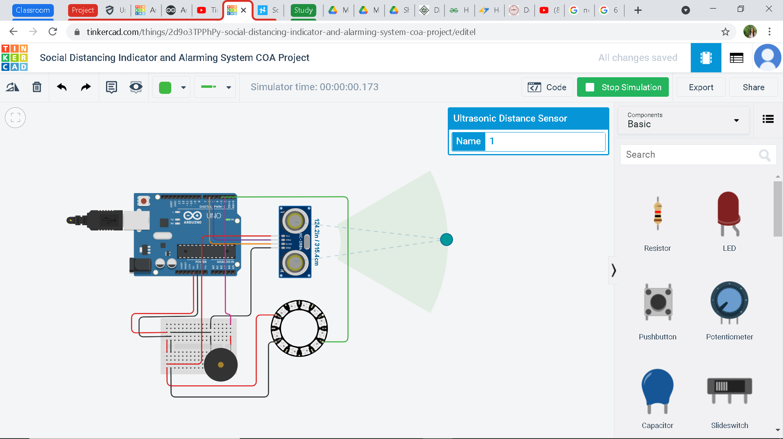

**CASE B: DISTANCE = 257 METERS (SAFE)**

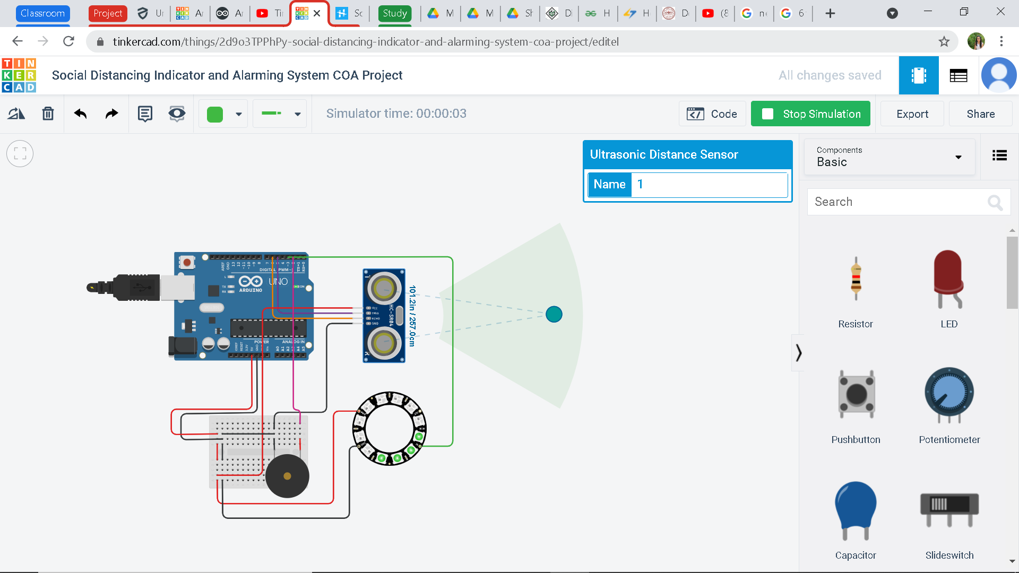

**CASE C: DISTANCE = 209 METERS ( )**

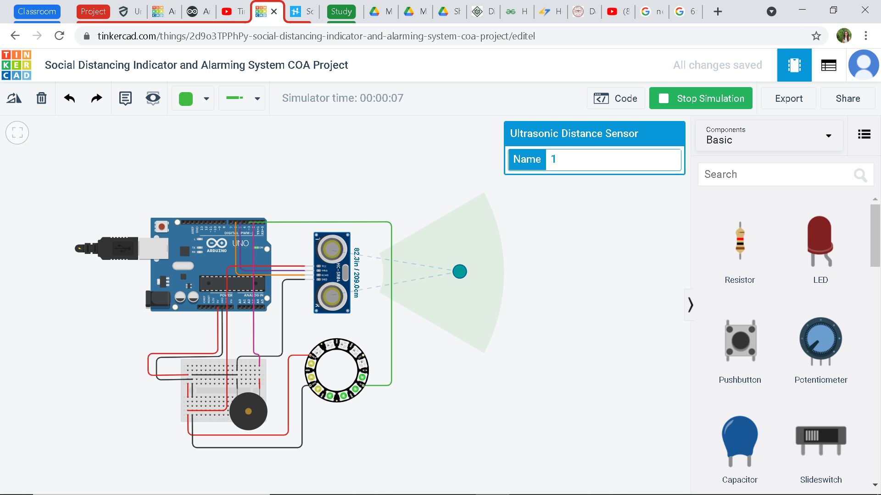

**CASE D: DISTANCE = 137 METERS (DANGER)**

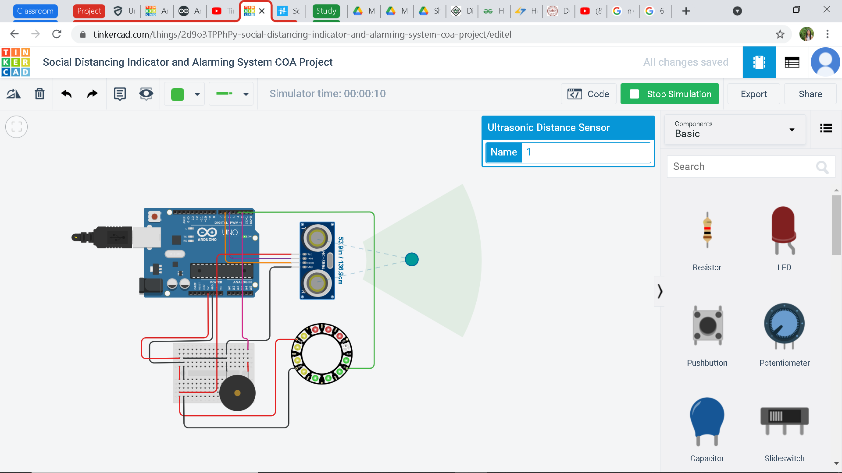

**CASE E: DISTANCE = DISTANCE < 100 METERS (DANGER) (BUZZER RINGS)**

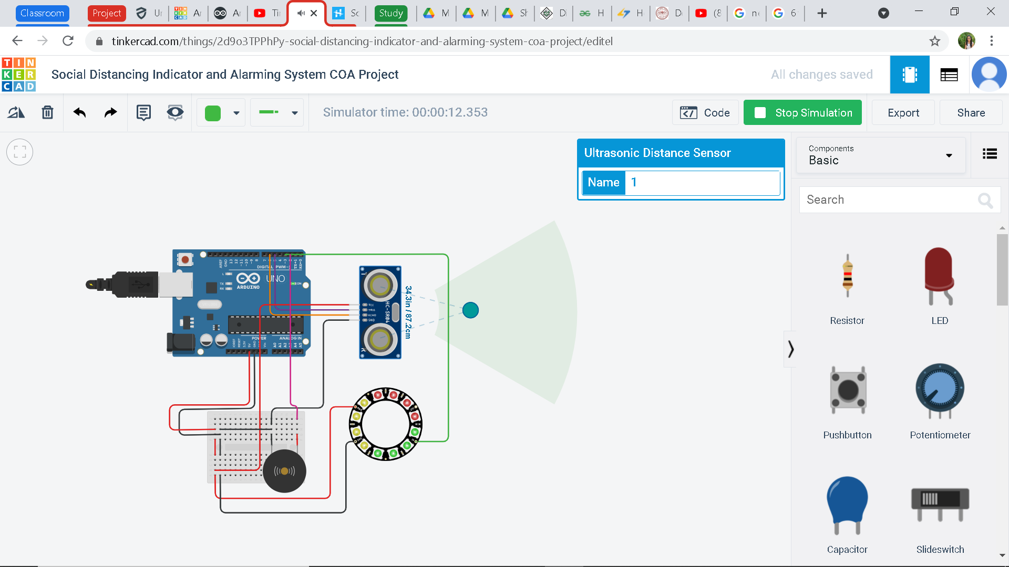

* **PRACTICAL USE**

The above circuit can be concealed in a box and can be tied around your arm. When the distance between you and other person is less than 1 meter this device turns on the buzzer and a vibration will occur indicating you have to maintain social distancing.

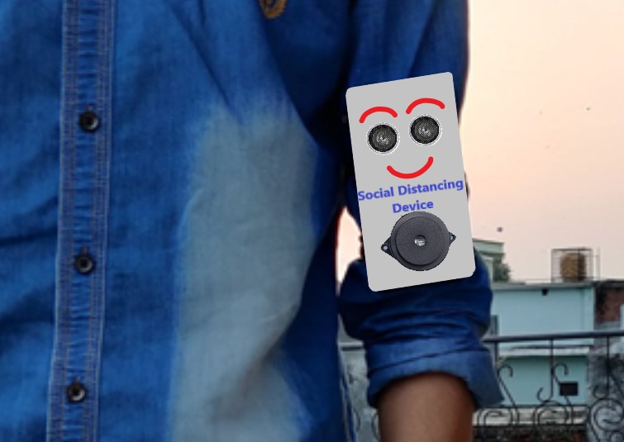

Using the circuit shown above, a social distancing alarm cap can be constructed which will have an ultrasonic sensor on all four directions, i.e., front, back, left or right directions, so that the circuit will alert you if you come close to anyone from any of the four directions. The cap fitted with four ultrasonic distance sensors connected to Arduino Uno will sense the minimum safe distance and will alert you through a buzzer.

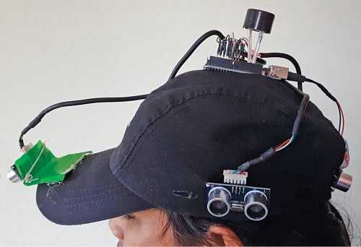

**SMART DISINFECTION AND SANITIZATION TUNNEL**

* **COMPONENTS**

|  |  |  |  |
| --- | --- | --- | --- |
| **SR. NO.** | **COMPONENT** | **SPECIFICATIONS** | **QUANTITY** |
| 1 | Arduino Uno R3 | R3 | 1 |
| 2 | PIR Sensor | 5V | 1 |
| 3 | Battery | 9V | 1 |
| 4 | Relay | SPDT | 1 |
| 5 | Resistors | 350Ω | 1 |
| 150 Ω | 1 |
| 6 | DC Motor | 9V | 1 |
| 7 | Red LED | 2V, 20mA | 1 |
| 8 | Green LED | 2V, 20mA | 1 |

* **DESCRIPTION OF COMPONENTS**
* **Arduino Uno R3**

The Arduino Uno is a microcontroller board based on the ATmega328. It has 20 digital input/output pins (of which 6 can be used as PWM outputs and 6 can be used as analog inputs), a 16 MHz resonator, a USB connection, a power jack, an in-circuit system programming (ICSP) header, and a reset button.  Programs can be loaded on to it from the easy-to-use Arduino computer program, [Arduino IDE](https://en.wikipedia.org/wiki/Arduino#Software) (Integrated Development Environment), via a type B [USB cable](https://en.wikipedia.org/wiki/USB_cable). It can be powered by the USB cable or by an external [9-volt battery](https://en.wikipedia.org/wiki/9-volt_battery), though it accepts voltages between 7 and 20 volts.



* **PIR SENSOR**

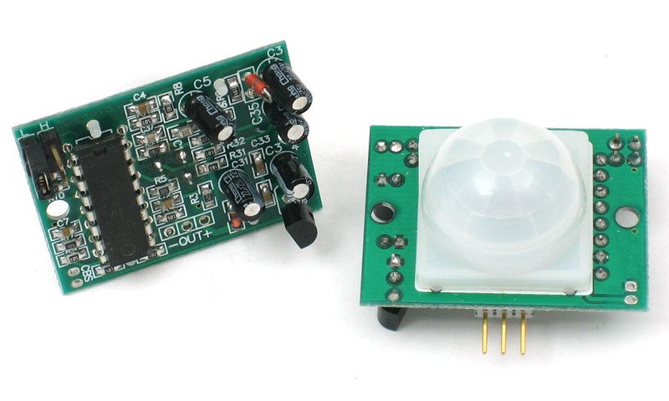

PIR sensors allow you to sense motion, almost always used to detect whether a human has moved in or out of the sensors range. PIRs are basically made of a pyroelectric sensor (which you can see below as the round metal can with a rectangular crystal in the center), which can detect levels of infrared radiation. Everything emits some low level radiation, and the hotter something is, the more radiation is emitted. That’s where the name of the sensor comes from, a Passive Infra-Red sensor. And the term “passive” means that sensor is not using any energy for detecting purposes, it just works by detecting the energy given off by the other objects. The sensor in a motion detector is actually split in two halves. The reason for that is that we are looking to detect motion (change) not average IR levels. The two halves are wired up so that they cancel each other out. If one half sees more or less IR radiation than the other, the output will swing high or low.

The module has just three pins, a Ground and a VCC for powering the module and an output pin which gives high logic level if an object is detected. Also it has two potentiometers. One for adjusting the sensitivity of the sensor and the other for adjusting the time the output signal stays high when object is detected. This time can be adjusted from 0.3 seconds up to 5 minutes.

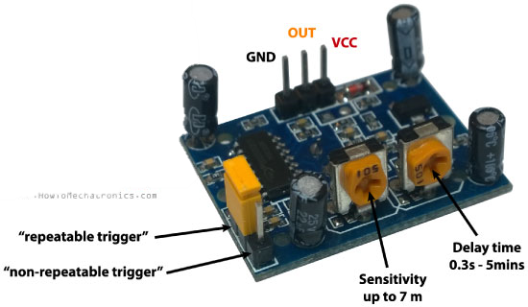

* **SPDT Relay**

[Relay](https://circuitdigest.com/article/relay-working-types-operation-applications) is an electromagnetic switch, which is controlled by small current, and used to switch ON and OFF relatively much larger current. Means by applying small current we can switch ON the relay which allows much larger current to flow. A relay is a good example of controlling the AC (alternate current) devices, using a much smaller DC current.  Commonly used Relay is **Single Pole Double Throw (SPDT) Relay**, it has five terminals as below:

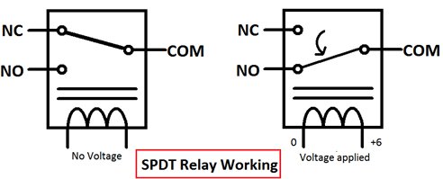

When there is no voltage applied to the coil, COM (common) is connected to NC (normally closed contact). When there is some voltage applied to the coil, the electromagnetic field produced, which attracts the Armature (lever connected to spring), and COM and NO (normally open contact) gets connected, which allow a larger current to flow.

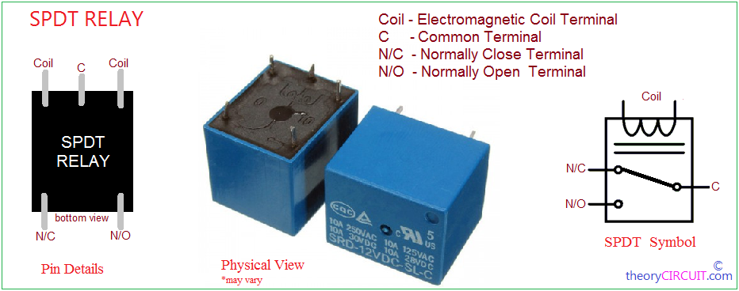

* **DC Motor**

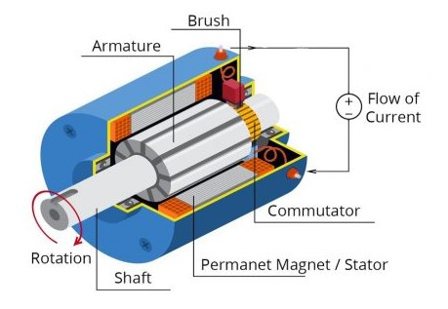

A DC motor is any of a class of rotary electrical motors that converts direct current electrical energy into mechanical energy. The most common types rely on the forces produced by magnetic fields. Nearly all types of DC motors have some internal mechanism, either electromechanical or electronic, to periodically change the direction of current in part of the motor.

DC motors were the first form of motor widely used, as they could be powered from existing direct-current lighting power distribution systems. A DC motor's speed can be controlled over a wide range, using either a variable supply voltage or by changing the strength of current in its field windings.

* **CIRCUIT**

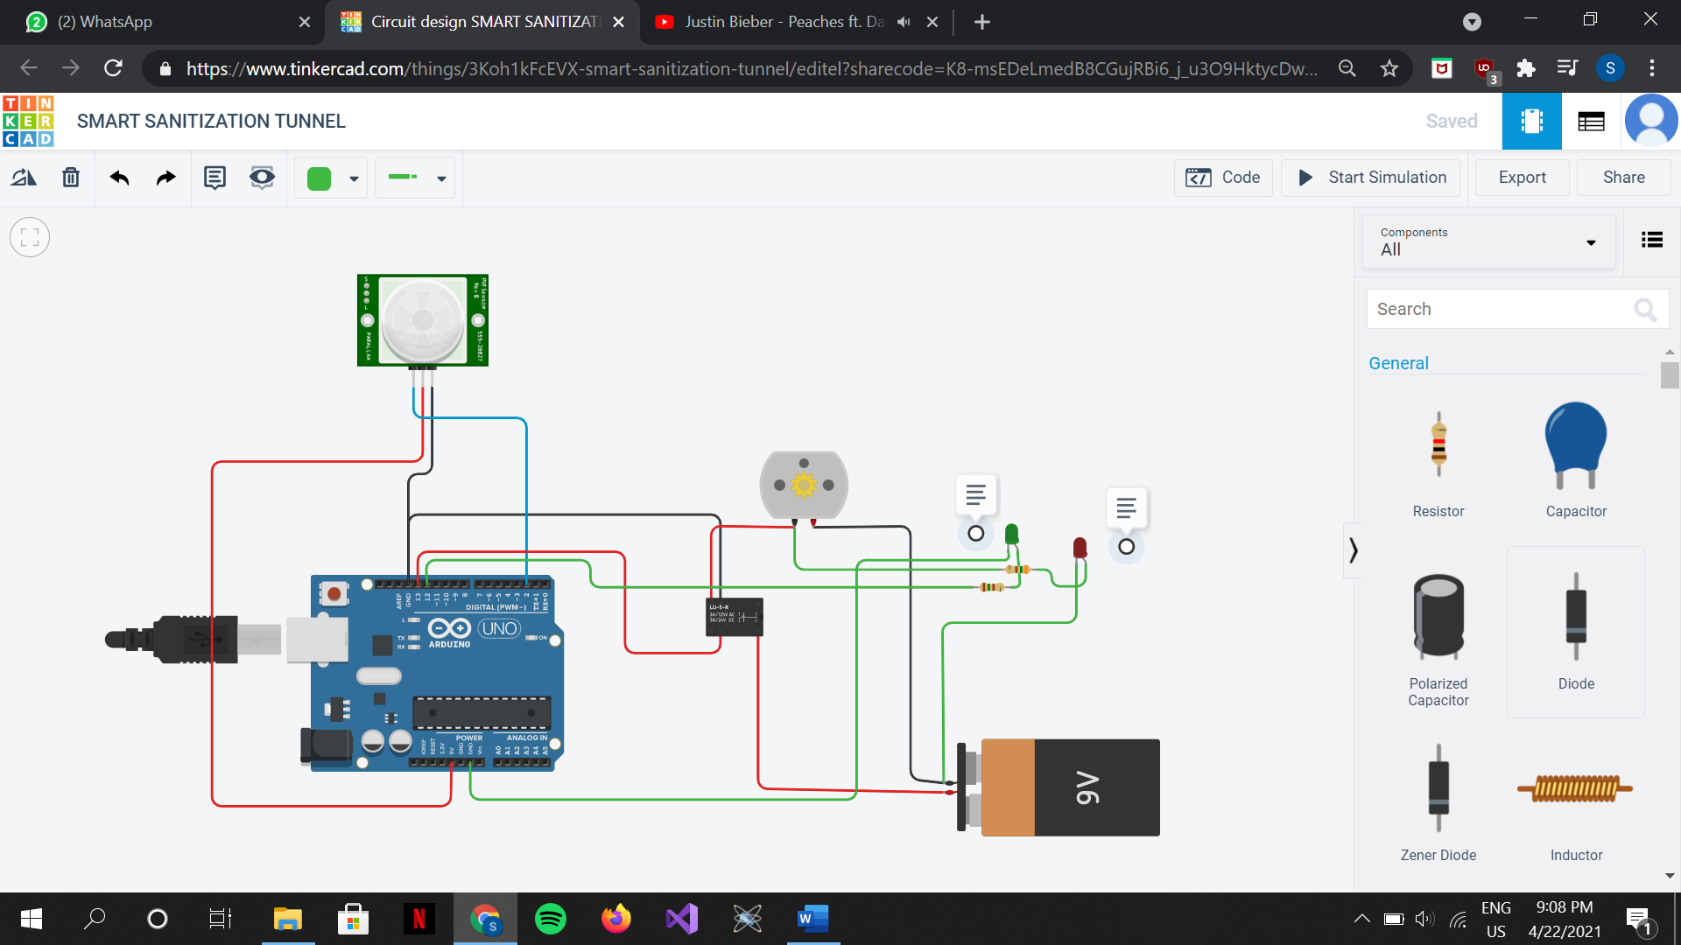

* **PRINCIPLE**

After a delay of 5000 µs, the green LED glows indicating that the person is sanitized and can step out and the tunnel is now free for the next person to enter.

If a person is detected, the DC motor starts turning. The red LED glows indicating that the sanitizer is being sprayed and that the tunnel is occupied.

The green LED glows indicating that the tunnel is free for a person to enter.

The PIR sensor detects whether a person has entered the tunnel

* **WORKING OF CIRCUIT**

The connections are made according to the circuit diagram shown above. The Arduino Uno board is connected with a PC using a USB cable. The code written in Arduino Uno IDE is loaded into the Arduino Uno board.

After powering up Arduino Uno board, the circuit becomes functional. 5 V supply is given to PIR sensor and 9V supply from the battery is given to common pin of SPDT relay and to the green LED. When a person comes in the range of the PIR sensor, it will detect a movement because the human body emits heat energy in a form of infrared radiation. This will give HIGH signal in the signal pin of PIR sensor. When the Arduino input pin receives HIGH signal from PIR sensor, voltage is applied across the coil of the SPDT relay. The magnetic field produced attracts the armature from NC pin to NO pin and hence COM and NO gets connected, which allows a larger current to flow to the DC motor. This activates the DC motor (that leads to sanitizer being sprayed) and hence the red LED. The green LED is set to LOW indicating the tunnel is in use. After a delay of 5000 µs, the relay is given LOW input and the green LED is given HIGH signal indicating the tunnel is free and the next person can enter.

* **CODE**

int relay= 13;

int Pir = 2;

int val = 0;

int LED= 12;

void setup()

{

pinMode(relay, OUTPUT);

pinMode(Pir, INPUT);

pinMode(LED, OUTPUT);

digitalWrite(LED, HIGH);

}

void loop()

{

val = digitalRead(Pir);

if(val == HIGH)

{

digitalWrite(relay, HIGH);

digitalWrite(LED, LOW);

delay(15000);

}

else

{

digitalWrite(relay, LOW);

delay(300);

}

digitalWrite(LED, HIGH);

}

* **SIMULATION ON TINKERCAD**

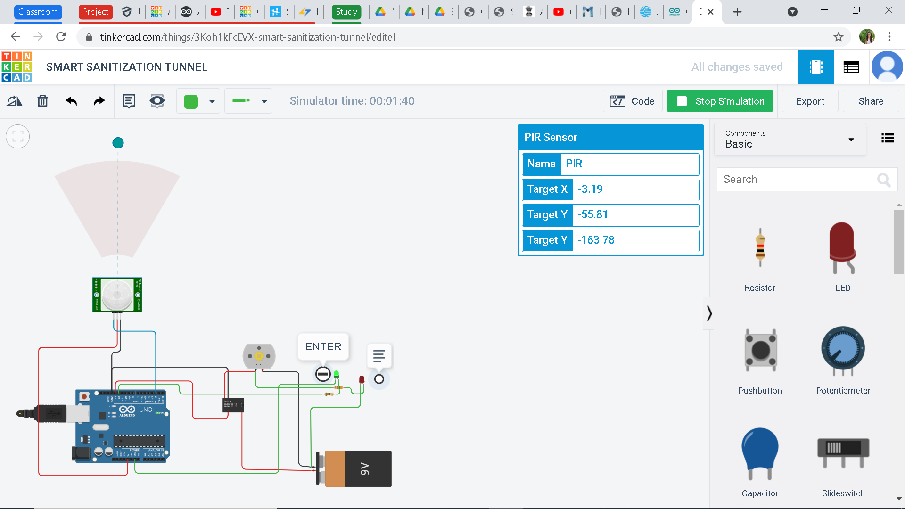

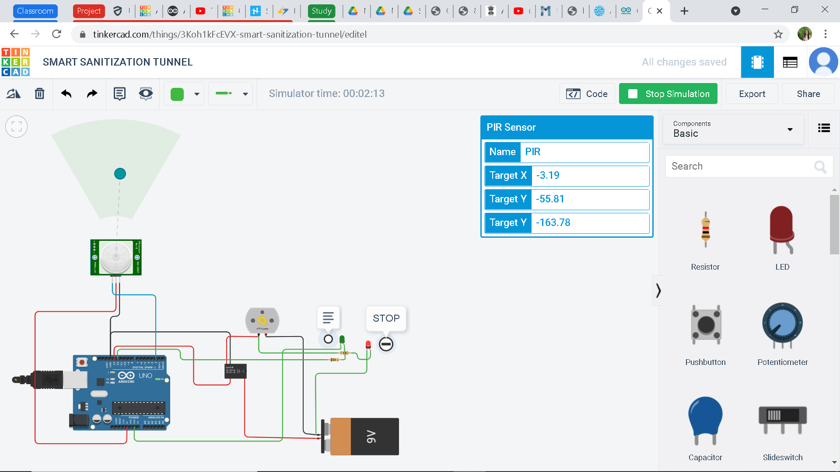

* **PRACTICAL USE**

The smart disinfection and sanitization tunnel can be used in public places to avoid the spread of virus.

* Food markets

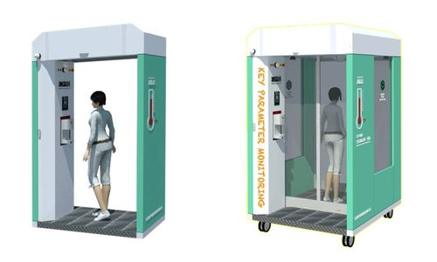

* Offices
* Shopping malls
* Airports
* Bus stops
* Railway stations
* Police stations
* College
* Hospitals
* Colony

**BIBLIOGRAPHY**

* <https://www.tinkercad.com/>
* <https://en.wikipedia.org/wiki/COVID-19>
* <https://store.arduino.cc/digital/create>
* <https://en.wikipedia.org/wiki/Digital_electronics>
* <https://www.javatpoint.com/computer-organization-and-architecture-tutorial>
* <https://learn.adafruit.com/pir-passive-infrared-proximity-motion-sensor/how-pirs-work>
* <https://www.keyence.co.in/ss/products/sensor/sensorbasics/ultrasonic/info/>
* <https://www.electroschematics.com/spdt-relay-switch/>